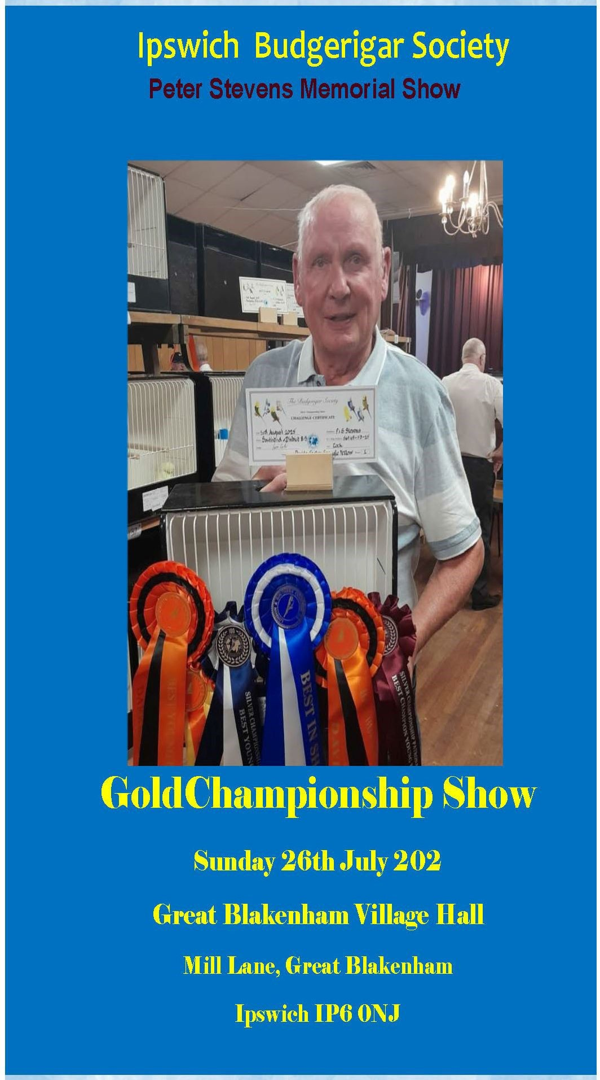

1

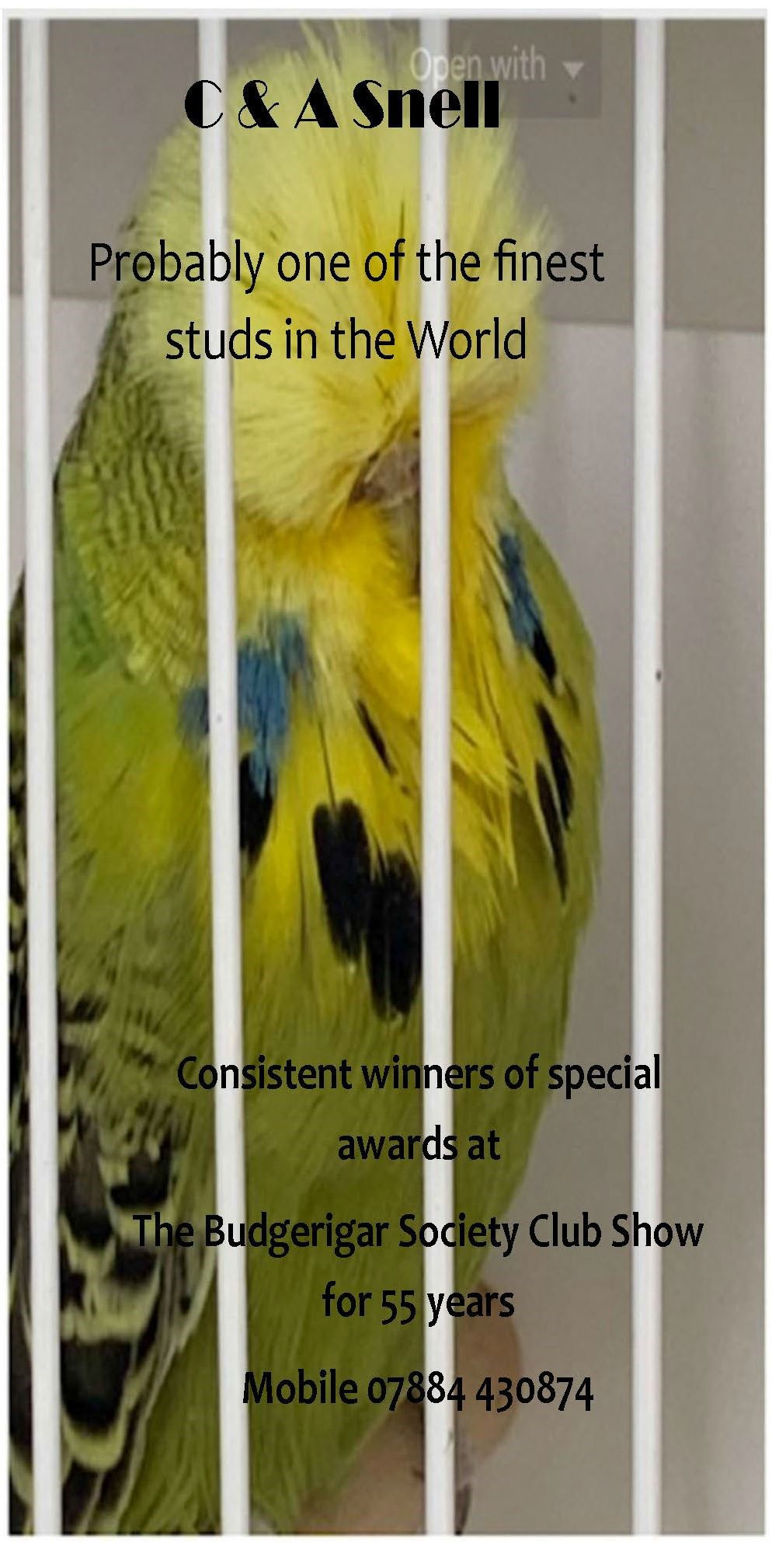

IPSWICH
BUDGERIGAR SOCIETY
PETER STEVENS MEMORIAL SHOW

GOLD CHAMPIONSHIP SHOW
TO BE HELD AT
GT. BLAKENHAM VILLAGE HALL, MILL LANE, GT. BLAKENHAM, IPSWICH, SUFFOLK IP6 0NJ

Sunday 26th July 2026
(BS Week Number 30)
OPEN SHOW OFFICIALS

SHOW ORGANISER - GHALIB AL-NASSER SHOW MANAGER - GEORGE McMILLAN SHOW SECRETARY - JANICE AL-NASSER BIO-SECURITY OFFICER - ANDY BROOKS

SOCIETY OFFICIALS
PRESIDENT - MARTIN FROST
CHAIRMAN - GHALIB AL-NASSER
SECRETARY - DARREN DUNNAGE
TREASURER - SANDRA STEVENS

SHOW SECRETARY

JANICE AL-NASSER - TEL: 01787 282332
EVENSTAR, PINKUAH LANE, PENTLOW, ESSEX CO10 7JW
EMAIL: janice.alnasser8@gmail.com

CLOSING DATE FOR ENTRIES - MONDAY 20th JULY

Please enclose 1st Class stamp S.A.E. with your Entry Form for return of
labels or pay £2.00 with the Entry Form
PLEASE NOTE: Only entries included in the catalogue are eligible for Patronage Awards and Society Specials. Members of Specialist Societies are requested to mark on their Entry Form the societies to which they are paid up members of, and include their code number

Entry Fee: £1.00 per cage Juniors: 50p per cage
Sales: £1.00 per cage (10% Commission)

Cheques should be made payable to Ipswich Budgerigar Society
ACCEPTANCE OF BIRDS: Sunday: 8.00 a.m. – 9.30 a.m.

REMEMBER TO QUOTE YOUR CPH NUMBER ON ENTRY FORM JUDGING COMMENCES AT 10.00 a.m.
SHOW OPENS TO THE PUBLIC: SUNDAY 2.00 p.m. - 4.00 p.m.

Admission to the Show: Free Catalogue: £2.00

For further information contact the Show Organiser Ghalib Al-Nasser - Tel: 07886 257833

Ploughman Lunch, Dessert, Tea or Coffee, at £10.00 each. Meals must be booked, and paid for, with Entry Forms.

If you are interested in Budgerigars why not join the Ipswich B.S. which caters for your special interest.
Secretary: Mr Darren Dunnage Tel: 07960 831748 email: ddunnage@icloud.com

VISITORS ARE WELCOME AT ALL MEETINGS HELD AT THE CONSTABLE MEMORIAL HALL, GANDISH ROAD, EAST
BERGHOLT, SUFFOLK CO7 6TP.
4th Thursday of each month commencing at 7.45 pm Subscriptions 2026: £10.00 adults, £5 Juniors.

JUDGES COLOUR ALLOCATION

Maurice Roberts LT. GREEN; DF BLUE; GREY; OPALINE GREEN; ALBINO; CREST; DF SPANGLE; DOM. PIED; RARE;

Brian Reese DF GREEN; SKYBLUE; CIN BLUE; OPALINE
CINNAMON; LUTINO; WHITEWING; SF SPANGLE GREEN; A.O.C.; TEAMS

Mark Gulley GREY GREEN; OPALINE BLUE; CIN GREEN;
YELLOW-WING; SF SPANGLE BLUE, REC.PIED; CLEARBODY; YELLOWFACE; PAIRS

ALL JUDGES TO JUDGE COLOUR BUDGERIGAR CLASSES/CCs FIRST
ALLOCATION FOR SECTION SPECIALS
Champion Any Age Maurice Roberts Champion Young Bird Brian Reese
Intermediate Any Age Mark Gulley Intermediate Young Bird Maurice Roberts Novice Any Age Brian Reese
Novice Young Bird Mark Gulley Junior Any Age Maurice Roberts Junior Young Bird Brian Reese

MAJOR SPECIALS ALLOCATION
All judges to be involved in judging the following Specials: BIS, Best A/A, Best A/A Opp.Sex, Best Y/B, Best Y/B Opp.Sex.

BUDGERIGAR PATRONAGES RECEIVED FOR THIS SHOW

Please tick box and give your numbers on entry form to nominate

Budgerigar Society | “A”
Lincolnshire & East Anglia BS | “B”
London & Southern Counties BS | “C”
South Midlands Budgerigar Society | “D”
Association of Specialist Budgerigar Societies | “E”
Lutino & Albino BBudgerigar Ssociety | “F”

TROPHIES FOR OPEN COMPETITION
Best Budgerigar in Show Doug Salmon Cup
Best Any Age in Show Society Cup
Best Young Bird in Show Keene Cup
Best Any Age Opposite Sex Society Cup
Best Young Bird Opposite Sex Society Cup
Best ChampionYoung Bird Cramphorn Cup
Best Intermediate Young Bird Fraser Cup
Best NoviceYoung Bird Roanoke Cup
Best Junior Young Bird Junior Cup
Best Team Society Trophy
Best Pair Society Trophy
Best Colour Budgerigar Society Trophy
Most Points by a Member Rafis Trophy

Trophies to be returned to Trophy Steward Darren Dunnage (07960 831748) in clean order ready for presentation at this year’s show.

SPECIALS OPEN TO ALL COMPETITORS
Best Budgerigar in Show Rosette & £25.00
Best Any Age in Show Rosette & £15.00
Best Young Bird in Show Rosette & £15.00 Best Any Age Opposite Sex in Show Rosette & £10.00 Best Young Bird Opposite Sex in Show Rosette & £10.00 Best Any Age & Young Bird in each Section Rosette & £7.00 2nd Best Any Age & Young Bird in each Section Rosette & £5.00 3rd Best Any Age & Young Bird in each Section Rosette & £3.00 4th—5th Best Any Age & Y/Birdin each Section Rosette
Best Junior Any Age & Young Bird Rosette & £5.00 2nd Best Junior Any Age & Young Bird Rosette
3rd Best Junior Any Age & Young Bird Rosette Best of each Colour Rosette
Best Pair Rosette & £5.00
Best Team Rosette & £5.00
Best Coloured Budgerigar Rosette & £5.00
Best Coloured Budgerigar Pair Rosette & £5.00
Best Coloured Budgerigar Team Rosette & £5.00
Country Wide Seed Voucher for Best Novice Young Bird &
Best Colour Budgerigar
SMOKING IN THE SHOW HALL IS NOT ALLOWED (Government Laws)

DON’T FORGET TO NOMINATE AND GIVE YOUR MEMBERSHIP NUMBERS THIS SHOW IS HELD UNDER THE RULES AND CONDITIONS OF THE BUDGERIGAR SOCIETY

This is a GOLD Championship Plus CB Add-On Patronage Show of the BUDGERIGAR SOCIETY, 22 Homefield Avenue, Morley, Leeds LS27 0DX.
Annual Subscription 2026 - £42.00, Related Partnership (same address)
£63.00, Senior Citizens & Reg Disabled £33.60, Juniors (aged 8.- 16)
£27.30. Joining/Re-joining fee £10.00 per member. (Subscription year: January to December). The Budgerigar Society reserves the right to use exhibitors' Names and Photographs in Publications.
All Showing Exhibitors must Sign an entry form prior to entering the birds at the show, Include the CPH Number and give the entry form to the Show officials. If this exhibitor refuse or doesn’t sign the form the birds cannot be accepted into the shows .
“Juniors in attendance at shows during show preparation and judging shall be accompanied by an adult family member or guardian and the show Manager informed of their attendance.” “There should be no trading or exchange of birds in the areas and car parks surrounding the show hall.”
Nominate “A”
For full details of patronage awards on offer and NOTES applicable to all levels of Patronage see the May/June edition of “The Budgerigar” or The Budgerigar Society website: www.budgerigarsociety.com

***********
This is an Affiliated Patronage of the LINCOLNSHIRE & EAST ANGLIA BUDGERIGAR SOCIETY. Subscription Secretary: Mr. M. Widdowson, 48 Everingtons Lane, Skegness, Lincs. PE25 1HN. Annual Subscriptions: Single £10.00, Partnership £10.00 per member, Husband & Wife £15.00, Junior, OAP & Disabled £8.00.

Nominate “B”

Rosette Best Any Age in each Section (excl. Junior) Rosette Best Young Bird in each Section (excl. Junior) Rosette Best Junior Budgerigar

******************
7

Mick Widdowson
Champion Breeder & Judge Most mainstream colours Plus - Crests and Slates

Birds usually for sale
Skegness, Lincolnshire.
Tel 01754 763193 Mobile 07766 741680

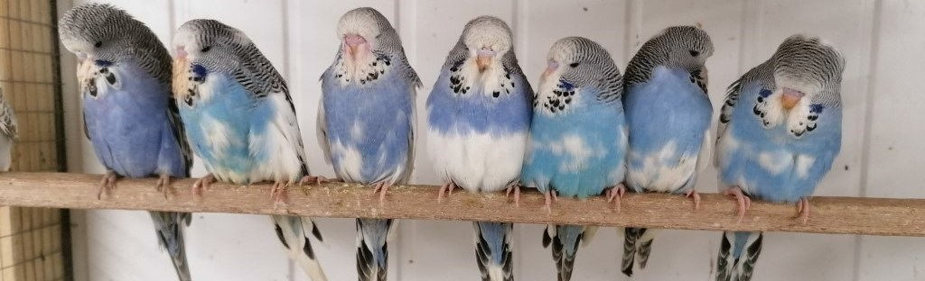8
S u f f o l k E x h i b i t i o n B u d g e r i g a r s

Quality exhibition Budgies variety of colours available. Visit www.suffolkbudgies.co.uk for full details and pictures of available birds. WhatsApp
07718184436 or email jgibbens@btinternet.com

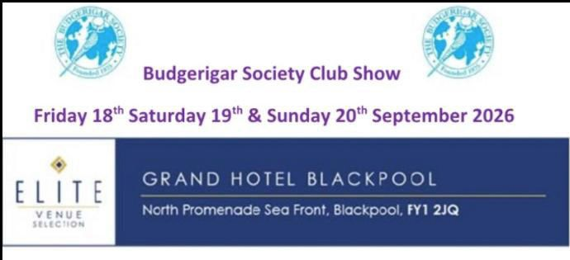

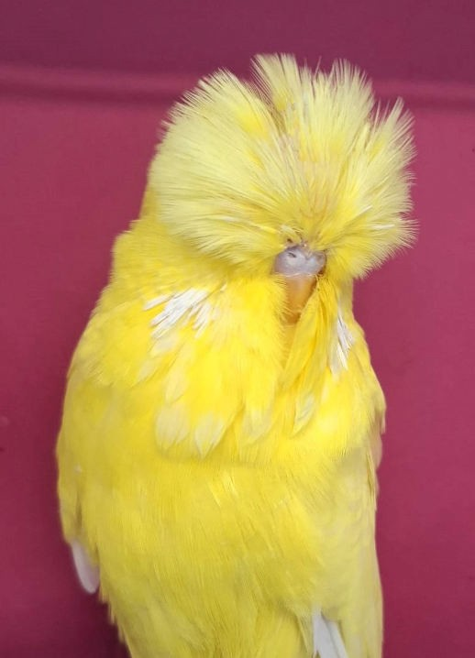Andy Brooks
Successful Intermediate Breeder & Exhibitor
Dark Factors Redeyes & Spangles

Many CCs won including Section Wins; Best Young Bird in Show

Two Colour Champion Lutinos
Penfold Cottage, Newton Green, Sudbury Suffolk CO10 0QJ
M: 07765 882044
andybrooks196331@gmail.com
9

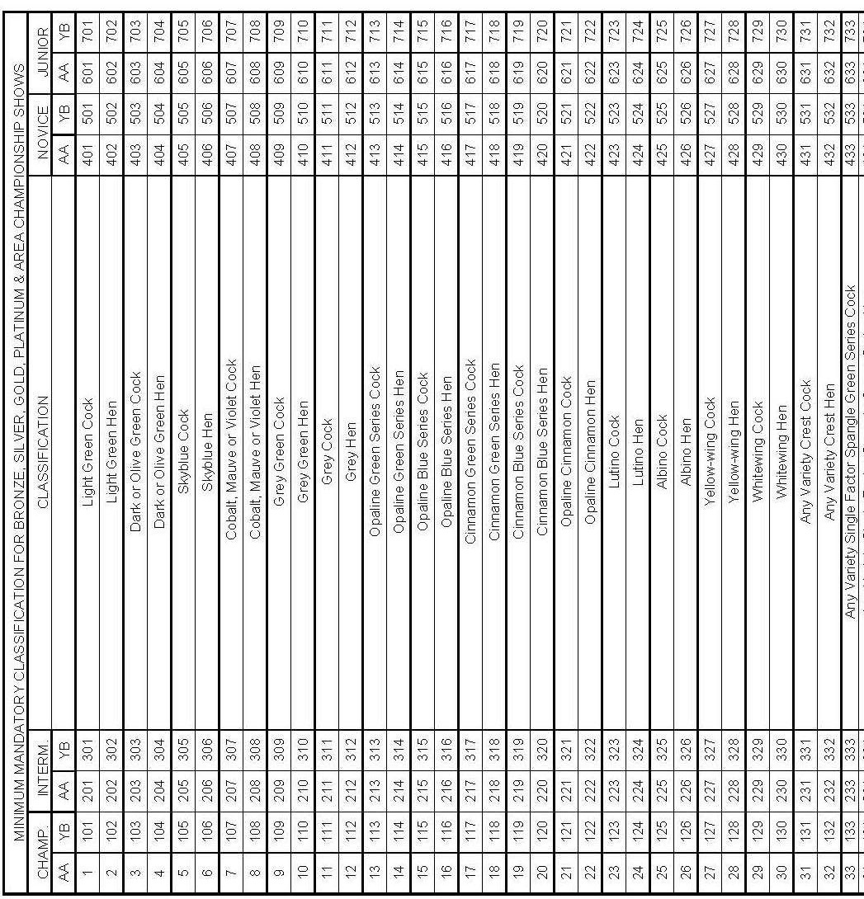

10

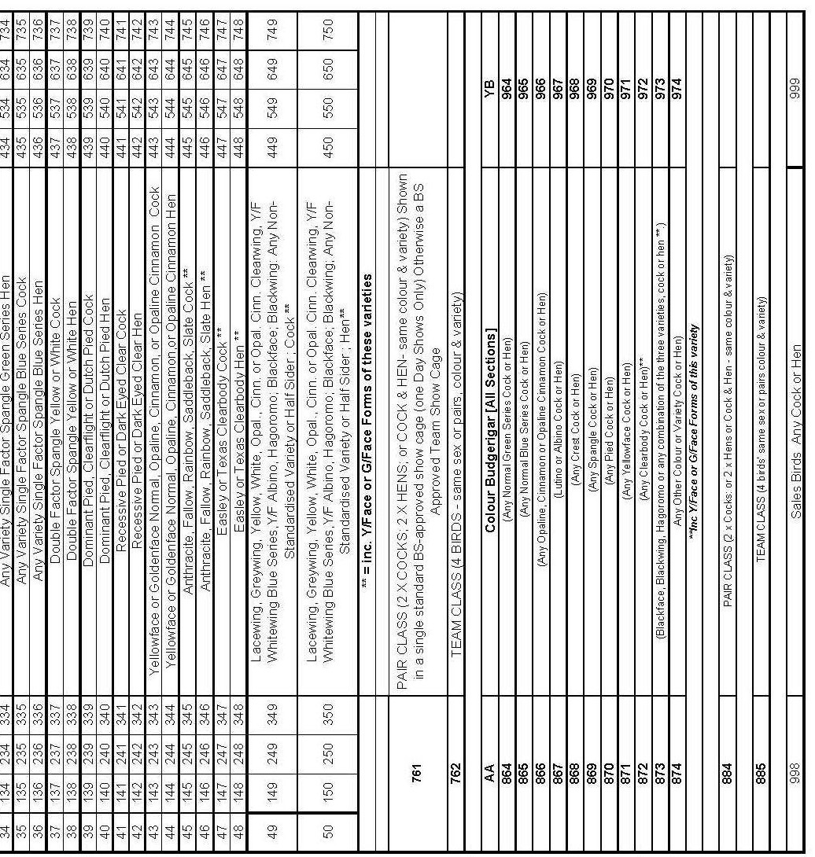

11

This is a Rosette patronage show of the LONDON & SOUTHERN COUNTIES BUDGERIGAR SOCIETY. Awards are for competition between paid-up members of the Society only. For details of Show Rules governing this patronage, please refer to our current rule book.
Subscriptions should only be sent to the subscription secretary: Mr. Wayne Greening, 3 Atlingworth Court, Brighton, East Sussex BN2 1PL.
Subscription Rates: £15.00 Single, £15.00 Partnerships per member,
£20.00 for any partnership living in the same household, £10.00 Senior Citizens over the age of 65, £10.. Disabled, £8.00 Junior (aged 8-16).
Exhibitors whose details do not appear in the Catalogue cannot compete for Specials.
Nominate “C”

Rosette Best in Show (Open Award) Rosette Best Any Age in each Section Rosette Best Any Age in each Section
Rosette Best Colour Budgerigar Any Age & Young Bird

* * * * * * * * * *
This is a Full Rosette Patronage Show of the SOUTH MIDLANDS BUDGERIGAR SOCIETY. Awards for competition between paid up members of the society only. Membership Secretary: Adrian Terheege, 80 High Street, Oakley, Bedfordshire MK43 7RH. Tel: 07984 430053 or email: adrian@ta1-budgerigar.co.uk
Subscriptions: £10 Single, £17 Partnership at the same address, £10 each member of a partnership at different address, £7 O.A.P. & Juniors.

Nominate “D”

Rosette Best Any Age in each Section Rosette Best Young Bird in each Section
*****************************

Association of Specialist Budgerigar Societies
(incorporating C.B.B.A., C.B.C, R.V&C.B.S, S.B.B.A & V.B.C)
Have awarded this show Championship Patronage for the following:

Crest: Rosette for Best Any Age & Young Bird Bannerettes for Best Young Bird in Section
Clearwing: Rosettes for Best Any Age & Young Bird in Whitewing & Yellow-wing.



Rare: Rosettes for Any Age & Young Bird in Rare , Clearbody & A.O.C.

Spangle: Rosettes for Best Any Age & Young Bird in Spangle Green, Spangle Blue & Double Factor Spangle.

Pied: Rosettes for Best Any Age & Young Bird in Dominant & Recessive Colour Budgerigar: Rosettes for Best Any Age & Young Bird
Annual Subscription, Adult £15, Partnership (same Address) £21, Partnership (Different address) £25, Senior Citizen & Disabled £12, Juniors £9, Life Membership x 20.

Membership Secretary. Mr Ian Brickwood, 60, Booth Lane South,
Westone, Northampton, Northants, NN3 3EP.
Email: ian.brickwood@btinternet.com
Membership number of the ASBS must be quoted.

Nominate “E”
************************************
This is a Silver Patronage show of the LUTINO & ALBINO BREEDERS SOCIETY Subs. Adults £8.00, Partnerships (at same address) £12.00 . O.A.P. and Disabled £6.00, Juniors (up to 16 years) Free. Subscriptions to Mr I. Brickwood, 60 Booth Lane South, Westone, Northampton. NN33EP Tel– 01604 785468. Patronage Secretary: C Thorne, 39, Sycamore Road, Birstall, Leicester. LE4 4LX Tel—01162 672159.
All membership enquiries to the Membership Secretary. L.A.B.S. members must provide their membership number. We offer to fully paid-up members the following awards. www.freewebs.com/budgerigar-labs
Nominate “F”
Rosette for Best Lutino & Albino Any Age. Rosette for Best Lutino & Albino Young Bird.
Ribbon for Best Lutino & Albino Young Bird in each Section Rosette for Best Junior Lutino and Albino.

This Show counts towards all membership awards to fully paid-up members only.

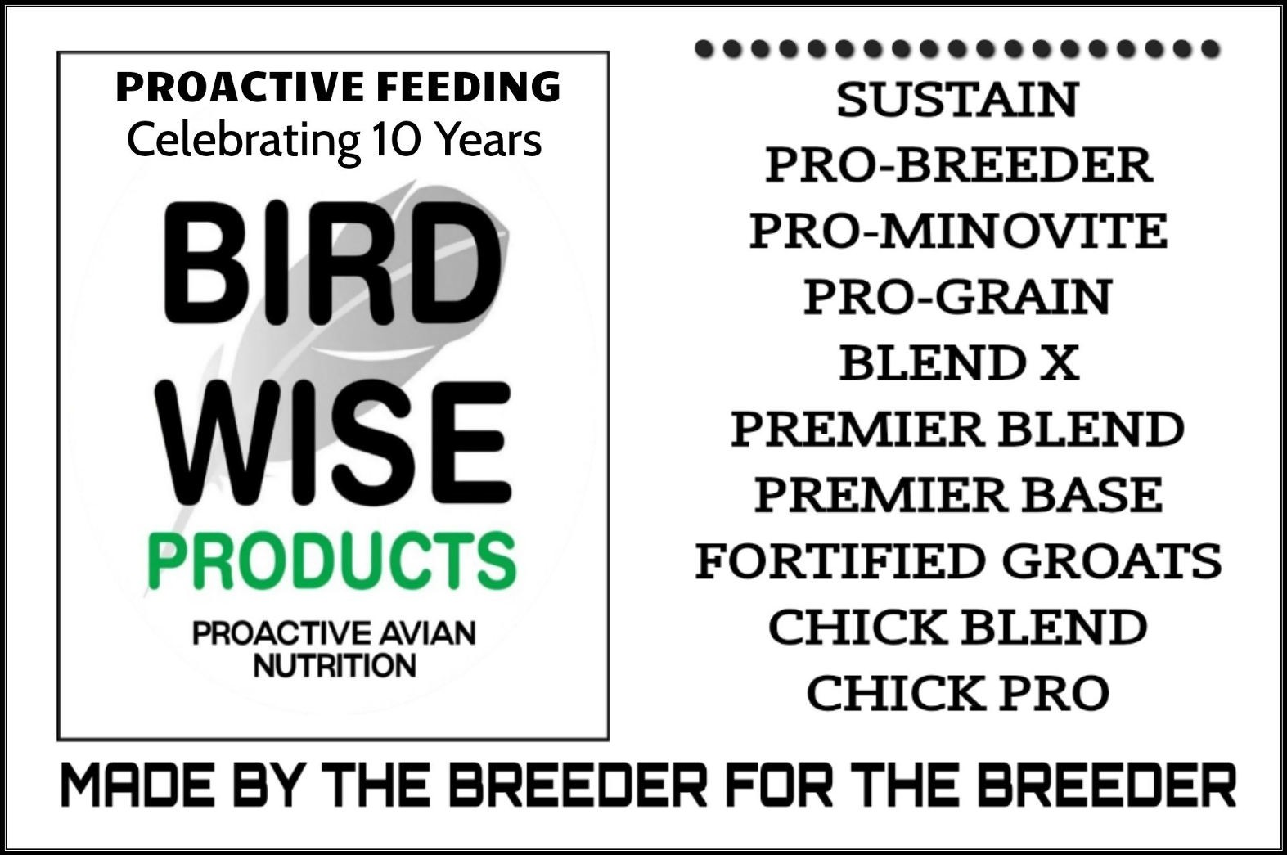
IAN THOROGOOD
CHAMPION BREEDER & PANEL JUDGE
BREEDER AND EXHIBITOR OF BOTH EXHIBITION & COLOUR BUDGERIGARS
PHONE: 07889 854127

SHOW RULES
- This Show is held under the Show Rules of the Budgerigar Society.
- Rules governing status of Juveniles, Novices or Intermediates, as laid down in the Year Book of the Budgerigar Society.
- No birds to be removed before 4.00 p.m. on Sunday of the show.
- No unauthorised persons will be allowed in the Show Hall whilst judging takes place.
- Every precaution will be taken to secure the welfare of the exhibits, but the Society will not be held responsible for any loss or damage to the birds, cases and boxes etc. that may happen from any cause whatsoever during the Show.
- Unauthorised persons are strictly forbidden to handle or give food to any exhibit at the Show. Any person offending in this respect will be liable to immediate removal from the hall.
- The Show Management Committee reserve the right to alter judges classes and appoint additional judges where deemed necessary.
- Anyone with definite grounds for complaint may lodge a written protest with the Show Manager by 3.00 p.m., depositing £10.00 pending investigations. The Show Management Committee will investigate the case, and their decision shall be final and binding. Should the protest be ruled as made without adequate grounds the deposit will be forfeited.
- Sales exhibitors are requested to state on entry form the price of each exhibit, all birds not for sale to be marked N.F.S. All birds for sale, must be closed rung and owner bred, will be sold at prices stated on entry form and 10% of the selling price will be deducted by the Society.
10 No birds can be claimed before 4.00 p.m. Application to be made to the Sales Steward
- All Budgerigar specials will be awarded to first prize winners only.
- No birds will be re-classified.
- No PHOTOGRAPHS to be taken without the permission of the SHOW MANAGER.
- The Open Show Committee shall have the power to decide in the case of any matter not covered by the foregoing rules, and their decision shall be final and binding.
- No trading/dealing of birds within the show hall or associated car park.
- All sales of birds to be carried out at the show through the show office.
- Juniors in attendance at shows during show preparation and
judging shall be accompanied by an adult family member or guard ian and the show Manager informed of their attendance.

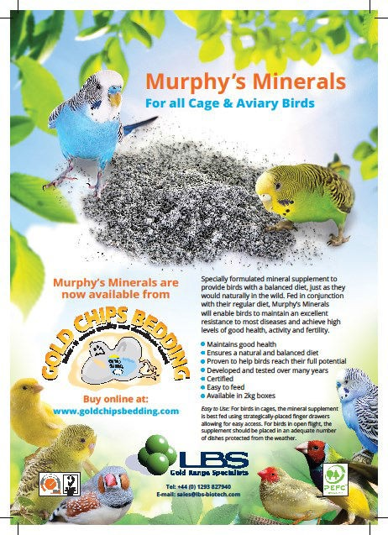

17

YOUR SUPPORT IS GREATLY APPRECIATED,
AND WE EXTEND OUR BEST WISHES FOR YOUR SUCCESS.

OUR THANKS TO ALL OUR MEMBERS WHO SPONSORED THE SHOW WITH THE COST OF SECTION ROSETTES, MONEY DONATION & ADVERTS IN THE SCHEDULE

Ghalib & Janice Al-Nasser, Alan Baker, Andy Brooks, Darren Dunnage,
Martin Frost, George McMillan, Bill Hewitt, Dave Gardner, John Gibbens, Sandra Stevens, Simon Gage,
Ian Thorogood, Stephen & Bill Squires, Chris Snell, Mick Widdowson
****************************
COUNTRY WIDE ARE SUPPLYING VOUCHERS FOR 2 BAGS OF SOCIETY BLEND 20 kg SEED TO BE AWARDED TO THE BEST NOVICE YOUNG BIRD AND BEST COLOUR BUDGERIGAR
COPDOCK MILL (SKYGOLD), GOLD CHIPS BEDDING AND BIRD WISE PRODUCTS ARE SPONSORING THE SHOW

Ipswich Budgerigar Society Championship Show Sunday 1st August 2027
Selling Classes 1001 Any variety cock or hen
1002 Any variety Colour Budgerigar

