**Ipswich Budgerigar Society Events Diary 2021.**

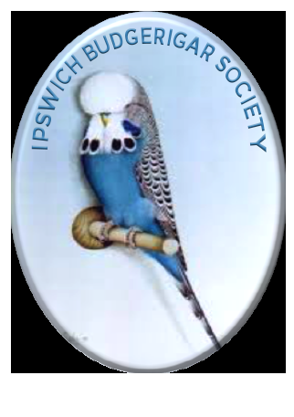*Suffolks Premier Club for Budgerigar Keepers.*

Meeting at the Constable Hall, Gandish Rd, East Bergholt.

19:45 – 22:00.

New Members are always welcome.

May 27h – Re-union Night and a Panel for questions and Answers.

June 24th Peters Swindle (2020 Birds).Show preparation Judge to be confirmed.

Colour Comp – Class 1- Any Normal Green Series bird Inc. Grey Green.

Class 2- Any Blue Series bird Including Grey

Class 3 – Any Pied Variety or Spangle (Inc double factor)

July 11th Members BBQ and Members Show at Stonefarm Up to a Max of 10 Birds per member for a mini

Schedule. Entry £10 which includes Bird entry meal and 5 Raffle tickets To be booked with Sandra

Judge Bev Hutt (TBC)

July 22nd Guest Speaker - for the Evening Parrot man Mr Colin O’Hara.

August 26th An evening with Ghalib Al-Nasser presentation on Club Show Management.

September 30th Guest Speaker- An Evening with Phil Reaney the BS President.

October 28th Peters Swindle 2021 Birds, Colour Competition, Award winner with most points

Class 4 – Any Normal Cinnamon any colour.

Class 5 – Any colour Opaline including Cinnamon Opaline

Class 6 – Any variety of Yellow Face (not including Pied or Spangle)

November 18th Sales night for Birds and Equipment and Auction of other items, Open night for members of the . public and invited guests of other local Bird clubs.

December 9th Members Christmas evening at a venue to be arranged

January 27th A.G.M