BUDGERIGAR SOCIETY

OPEN SILVER CHAMPIONSHIP SHOW

TO BE HELD AT
GT. BLAKENHAM VILLAGE HALL, MILL LANE,
GT. BLAKENHAM, IPSWICH, SUFFOLK IP6 0NJ

Sunday 28th July 2019
(BS Week 30)

OPEN SHOW OFFICIALS
JOINT SHOW MANAGERS - GRAHAM BARTON &
GEORGE McMILLAN
SHOW SECRETARY - PETER STEVENS
BIO SECURITY OFFICER - ANDY HARVEY

SOCIETY OFFICIALS
PRESIDENT - SANDRA STEVENS
CHAIRMAN - BILL SQUIRES
SECRETARY - BRIAN J BOYES
TREASURER - SUSAN Y BOYES

SHOW SECRETARY
PETER STEVENS - TEL: 01206 271382
STONEFIELD FARM GREYHOUND HILL LANGHAM ESSEX CO4 5QF EMAIL:- PETERSTEVENS194@GMAIL.COM

CLOSING DATE FOR ENTRIES - MONDAY 22nd JULY
Please enclose S.A.E. with your Entry Form for return of labels
No telephone entries after 8 pm

PLEASE NOTE: Only entries included in the catalogue are eligible for Patronage Awards and Society Specials. Members of Specialist Societies are requested to mark on their Entry Form the societies to which they are paid up members of, and include their code number
Entry Fee: 60p per cage Entries after 15 birds FREE except
Sales Classes
Juniors: 30p per cage
Sales: 60p per cage (10% Commission)

Cheques should be made payable to Ipswich Budgerigar Society

ACCEPTANCE OF BIRDS: Saturday: 6.00 p.m. - 7.30pm
Sunday: 7.30 a.m. - 9.00am

JUDGING COMMENCES AT 9.30 a.m.

SHOW OPENS TO THE PUBLIC: SUNDAY 2.00 p.m. - 4.00 p.m.

Admission to the Show: Free
Catalogue: £2.00
(price includes raffle ticket for a bag of seed)

Stewards are required for all Sections - Please mark the box on Entry Form.

For further information contact the Show Managers
Graham Barton - Tel: 07795 571124 or
George McMillan - Tel: 01255 679362

Hot Lunches, Sweet, Tea or Coffee, at £8.00 each.
Meals may be booked, and paid for, with Entry Forms.
SHOW RULES
- This Show is held under the Show Rules of the Budgerigar Society.
- Rules governing status of Juveniles, Novices or Intermediates, as laid down in the Year Book of the Budgerigar Society.
- No birds to be removed before 4.00 p.m. on Sunday of the show.
- No unauthorised persons will be allowed in the Show Hall whilst judging takes place.
- Every precaution will be taken to secure the welfare of the exhibits, but the Society will not be held responsible for any loss or damage to the birds, cases and boxes etc. that may happen from any cause whatsoever during the Show.
- Unauthorised persons are strictly forbidden to handle or give food to any exhibit at the Show. Any person offending in this respect will be liable to immediate removal from the hall.
- The Show Management Committee reserve the right to alter judges classes and appoint additional judges where deemed necessary.
- Anyone with definite grounds for complaint may lodge a written protest with the Show Manager by 3.30 p.m., depositing £10.00 pending investigations. The Show Management Committee will investigate the case, and their decision shall be final and binding. Should the protest be ruled as made without adequate grounds the deposit will be forfeited.
- Sales exhibitors are requested to state on entry form the price of each exhibit, all birds not for sale to be marked N.F.S. All birds for sale, must be closed rung and owner bred, will be sold at prices stated on entry form and 10% of the selling price will be deducted by the Society.
10 No birds can be claimed before 4.00 p.m. Application to be made to the
Sales Steward
- All Budgerigar specials will be awarded to first prize winners only.
- No birds will be re-classified.
- No PHOTOGRAPHS to be taken without the permission of the SHOW MANAGER. Brian J Boyes of BJB Images will be the official show photographer and available to photograph you and your winning birds. A4 Gallery Quality Prints will be available at £10.00 including P&P.
- The Open Show Committee shall have the power to decide in the case of any matter not covered by the foregoing rules, and their decision shall be final and binding.
- No trading/dealing of birds within the show hall or associated car park.
- All sales of birds to be carried at the show through the show office.
- Juniors in attendance at shows during show preparation and judg ing shall be accompanied by an adult family member or guardian ₁₉ and the show Manager informed of their attendance.
Rosette for Best Lutino & Albino Young Bird Rosette for Best Junior Lutino & Albino

This Show counts towards all membership awards to fully paid up members only.

*******************************

This is an Open Rosette Patronage Show of the
EXHIBITION BUDGERIGAR FORUM who offer the following OPEN
awards. ww.exhibitionbudgerigarforum.co.uk

Nominate “H”
Best Young Bird in Show Rosette

***************************
This show has received Open Patronage from the
MID ESSEX BUDGERIGAR SOCIETY Section Winners - Rosette The Mid Essex Budgerigar Society meets on the first Thursday of the month at Bicknacre Memorial Hall, Bicknacre Road, Bicknacre, Essex CM3 4ES and welcomes new members.
For more details contact the Secretary Mr James Folly please visit their website.

Nominate “I”
18

If you are interested in Budgerigars why not join this Society which caters for your special interest.
Secretary: Mr Brian J Boyes Tel: 07786 553800 email: secretary.ipswich.bs@gmail.com

VISITORS ARE WELCOME AT ALL MEETINGS HELD AT THE
CONSTABLE MEMORIAL HALL, GANDISH ROAD, EAST BERGHOLT, SUFFOLK CO7 6TP.
Subscriptions: £5.00 for all categories.

JUDGES COLOUR ALLOCATION

Chris Snell (SNE11) LT. GREENS; OPALINE BLUES; CIN GREENS,
ALBINOS; DF SPANGLES, DOM. PIEDS;
YELLOWFACES

Geoff Tuplin (GT1) SKYBLUES; OPALINE CINNAMONS;
SF SPANGLE GREENS; CRESTS, RARES, A.O.C. +
COLOURED BUDGERIGARS.

Allan Michael COBALTS, GREY GREENS; CIN BLUES; (MICA1)
(MICA1) YELLOW-WINGS; SF SPANGLE BLUES, REC. PIEDS

Ken Brockwell (KB1) DK. GREENS, GREYS; OPALINE GREENS;
LUTINOS; WHITEWINGS; CLEARBODYS+ PAIRS &
TEAMS

ALLOCATION FOR SECTION SPECIALS

Champion Any Age | Chris Snell
Champion Young Bird | Geoff Tuplin
Intermediate Any Age | Allan Michael
Intermediate Young Bird | Ken Brockwell
Novice Any Age | Ken Brockwell
Novice Young Bird | Allan Michael
Junior Any Age | Geoff Tuplin
Junior Young Bird | Chris Snell

MAJOR SPECIALS ALLOCATION

All judges to be involved in judging the following Specials:
BIS, Best A/A, Best A/A Opp.Sex, Best Y/B, Best Y/B Opp.Sex.
Partnerships, £5.00 Juniors, Life Membership 20 x Annual Fee.

Patronage Secretary: Mr. N. Humby, 16 Kendall Close, North Walsham, Norwich, Norfolk NR28 0HJ.
Fully paid up members must nominate C.B.B.A. including membership number. Www.clearwing.co.uk

Nominate “F”

Best Yellow-wing & White-wing Any Age - Rosette Best Yellow-wing & White-wingYoung Bird - Rosette
Best Yellow-wing & Whitewing Any Age in each Section -
Section Head Award
Best Yellow-wing & Whitewing Young Bird in each Section -
Section Head Award
Best Junior Yellow-wing & White-wing - Award of Merit *
* The Junior awards will be dispatched by the Patronage
Secretary
All points won at this Show count towards the Clearwing Exhibitor of the Year Awards

**********************

This is a Silver Patronage show of the LUTINO & ALBINO BREEDERS SOCIETY Subs. Adults £8.00, Partnerships (at same address) £12.00 . O.A.P. and Disabled £6.00, Juniors (up to 16 years) Free. Subscriptions to Mr I. Brickwood, 60 Booth Lane., South Westone, Northampton. NN33EP Tel– 01604 785468. Patronage Secretary: C Thorne, 39,Sycamore Road, Birstall, Leicester. LE4 4LX 01162672159.
All membership enquiries to the Membership Secretary.
L.A.B.S. members must provide their membership number. We offer to fully paid-up members the following awards. www.freewebs.com/budgerigar-labs

Nominate “G”

Rosette for Best Lutino & Albino Any Age.
17

Nominate “D”

Best Any Age in each Section - Rosette
Best Young Bird in each Section - Rosette

*****************************

Association of Specialist Budgerigar Societies
(incorporating C.B.C,R.V&C.B.S, S.B.B.A & V.B.C) Have awarded this show Patronage for the following:

Crest: Rosette for Best Any Age & Young Bird Bannerettes for Best in Section .
Rare: Rosettes for Any Age & Young Bird in Rare , Clearbody & A.O.C.

Spangles: Rosettes for Best Any Age & Young Bird in Spangle Green, Spangle Blue & Double Factor Spangle.

Pied: Rosettes for Best Any Age & Young Bird in Dominant & Recessive in each Section.

Annual Subscription, Adult £12, Partnership (same Address) £18, Partnership (Different address) £22, Senior Citizen & Disabled £9, Juniors £9, Life Membership x20.

Membership Secretary. Mr Ian Brickwood, 60, Booth Lane South, Westone, Northampton, Northants, NN3 3EP. Email: ian.brickwood@btinternet.com

Membership number of the ASBS must be quoted.

Nominate “E”

************************************

This is a Full Patronage Show of the CLEARWING BUDGERIGAR BREEDERS ASSOCIATION. Membership
Secretaries: Margaret & Bill Walker, 35 Woodsford Grove, Clifton
Estate, Notts. NG11 8FG. Annual Subs: £10.00 Single, £12.00 Partnership (same household), £9.50 per member other
16
BUDGERIGAR PATRONAGES RECEIVED FOR THIS SHOW

Please tick box and give your numbers on entry form to nominate

Budgerigar Society | “A”
London & Southern Counties BS | “B”
Lincolnshire & East Anglia B & FB Society | “C”
South Midlands Budgerigar Society | “D”
Association of Specialist Budgerigar Societies | “E”
Clearwing Budgerigar Breeders Association | “F”
Lutino & Albino Budgerigar Society | “G”
Exhibition Budgerigar Forum | “H”
Mid Essex Budgerigar Society “I”
TROPHIES FOR OPEN COMPETITION

Best Budgerigar in Show | Doug Salmon Cup
Best Any Age in Show | Society Cup
Best Young Bird in Show | Keene Cup
Best Any Age Opposite Sex | Society Cup
Best Young Bird Opposite Sex | Society Cup
Best ChampionYoung Bird | Cramphorn Cup
Best Intermediate Young Bird | Fraser Cup
Best NoviceYoung Bird | Roanoke Cup
Best Junior Young Bird | Junior Cup
Best Team | Society Trophy
Best Pair Society Trophy
Best Colour Budgerigar Society Trophy

Trophies to be returned to Trophy Steward Bill Squires (01473 715513) in clean order ready for presentation at this year’s show.

SPECIALS OPEN TO ALL COMPETITORS

Best Budgerigar in Show Rosette & £50.00 Best Any Age in Show Rosette & £25.00 Best Young Bird in Show Rosette & £25.00 Best Any Age Opposite Sex in Show Rosette & £15.00
Best Young Bird Opposite Sex in Show Rosette & £15.00 Best Any Age & Young Bird in each Section Rosette & £10.00 2nd Best Any Age & Young Bird in each Section Rosette & £5.00 3rd Best Any Age & Young Bird in each Section Rosette & £3.00
4th—5th Best Any Age & Y/Birdin each Section Rosette
Best Junior Any Age & Young Bird | Rosette & £5.00
2nd Best Junior Any Age & Young Bird | Rosette & £3.00
3rd Best Junior Any Age & Young Bird | Rosette & £2.00
Each CC winner will receive | Rosette & £5.00
Best Pair & Best Team | Rosette & £20.00
2nd Best Pair & Best Team | Rosette & £10.00
3rd Best Pair & Best Team | Rosette & £5.00
Best Coloured Budgerigar | Rosette & £10.00
Best Coloured Budgerigar Pair | Rosette & £10.00
Best Coloured Budgerigar Team | Rosette & £10.00

Country Wide Seed Voucher for Best Pair & Best Team

SMOKING IN THE SHOW HALL IS NOT ALLOWED (Government Laws)

DON’T FORGET TO NOMINATE AND GIVE YOUR MEMBERSHIP NUMBERS

NEXT YEAR’S SHOW WILL BE HELD ON 26TH JULY 2020

THIS SHOW IS HELD UNDER THE RULES AND CONDITIONS OF THE
BUDGERIGAR SOCIETY

This is a Silver Championship Patronage Show of the
BUDGERIGAR SOCIETY, 6 Toutie Street, Alyth, Blairgowrie,
Perthshire PH11 8BP. Annual Subscription 2019- £27.50, Related Partnership (same address) £41.25, Senior Citizens & Reg Disabled £22.00, Juniors (aged 8.- 16) £17.90. Joining/Re-joining fee £7.50 per member. (Subscription year: January to December)
Special Offer to new members: join in 2019 and get free membership for 2020.
“Juniors in attendance at shows during show preparation and judging shall be accompanied by an adult family member or guardian and the show Manager informed of their attendance.”
“There should be no trading or exchange of birds in the areas and car parks surrounding the show hall.” Nominate “A”
For full details of patronage awards on offer and NOTES applicable to all levels of Patronage see the May/June edition of “The Budgerigar” or The Budgerigar Society website: www.budgerigarsociety.com
This is a Rosette Patronage Show of the LONDON & SOUTHERN COUNTIES BUDGERIGAR SOCIETY. Awards are for competition between paid-up members of the Society only. For details of Show Rules governing this patronage please refer to our current rule book. Subscriptions should be sent to Mr Paul Tiller (4 Painshill House, Painshill Park, Cobham, Surrey KT11 1DL). Subscription Rates: £13.00 Single, £13.00 partnerships per member, £15.00 Any partnership living at the same address, Family - one or both parents paying the subscription as above plus £1.00 for each person under 16 years, £8.00 Senior Citizens over the age of 65 & Disabled, £6.00
Junior (aged 8-16). Exhibitors whose details do not appear in the
Catalogue cannot compete for Specials
Nominate “B”

Best Champion, Intermediate, Rosette
Novice & Junior A/A

Best Champion, Intermediate, Rosette Novice & Junior Y/B

- * * * * * * * * *

This is an Affiliated Patronage Show of the LINCOLNSHIRE & EAST ANGLIA BUDGERIGAR SOCIETY. Subscription Secretary: Mr. M.
Widdowson, 48 Everingtons Lane, Skegness, Lincs. PE25 1HN.
Annual Subscriptions: Single £10.00, Partnership £10.00 per member, Husband & Wife £15.00, Junior, OAP & Disabled £8.00.

Nominate “C”

Best Any Age & Young Bird in each Section excl. Junior - Rosette 2nd Best Young Bird in each Section excl. Junior - Rosette
Best Junior Budgerigar - Rosette

- * * * * * * * * *

This is a Full Rosette Patronage Show of the SOUTH MIDLANDS BUDGERIGAR SOCIETY. Awards for competition between paid up members of the society only. Membership Secretary: David Turner, Green Tye Farmhouse, Green Tye, Much Hadham, Herts. SG10 6JJ. Tel: 01279 842941.

YOUR SUPPORT IS GREATLY APPRECIATED,
AND WE EXTEND OUR BEST WISHES FOR YOUR SUCCESS.

OUR THANKS TO ALL OUR MEMBERS WHO SPONSORED
THE SHOW WITH THE COST OF SECTION ROSETTES,
MONEY DONATION & ADVERTS IN THE SCHEDULE

Ghalib & Janice Al-Nasser, Mick Anzara,
Peter Barber, Graham Barton,
Brian McCelland, Geoff Murrells, Peter & Sandra Stevens

****************************
Brian McCelland for sponsoring Millet sprays to be awarded to Junior Winners.

*************************

COUNTRY WIDE ARE SUPPLYING VOUCHERS FOR 2 BAGS OF SOCIETY BLEND 20 kg SEED TO BE AWARDED TO THE BEST PAIR AND THE BEST TEAM.

COPDOCK MILL ARE GIVEN BAGS OF SEED FOR BEST IN
EACH ADULT SECTION WINNERS AND MOST & 2ND MOST BENCHED BIRDS BY AN EXHIBITOR

GOLD CHIPS BEDDING ARE PROVIDING BAGS FOR 2ND BEST IN EACH SECTION & 2ND BEST PAIR & TEAM
*****************

NO SMOKING IN THE SHOW HALL AT ANY TIME
20

15

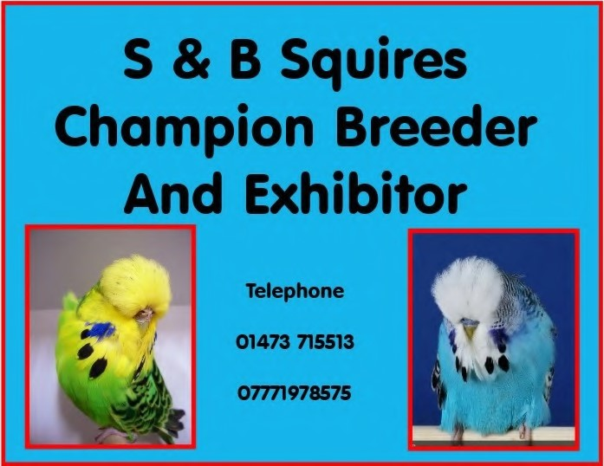
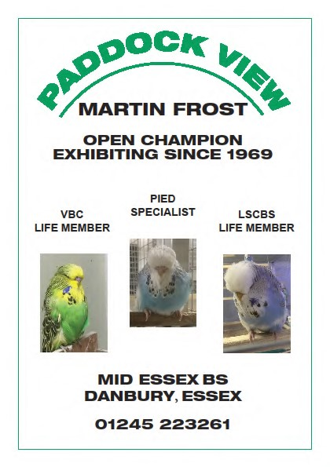
Ipswich Budgerigar Society Championship Show

Sunday 26th July 2020
Gt Blakenham Village Hall,
Mill Lane,
Gt Blakenham,
Ipswich IP6 ONJ
14

George.E.McMillan

AP BROOKS Plastering

Andy Brooks

Penfold Cottage
Newton Green, Sudbury
Suffolk CO10 0QJ
M: 07765882044

apbplastering@hotmail.co.uk

B.S. GEM1
Champion Breeder
& Exhibitor

Most colours kept
Frinton-on-Sea, Essex
Tel:- 01255679362
DAVID & LINDA RAFIS
CHAMPION BREEDER

Anthracites, Texas Clearbodies,
Clearbody Splits & Clearwings
Blue or Green Series
Crests, Tufts, & Crest Bred/Crest
Related

Telephone 01394 420325

13
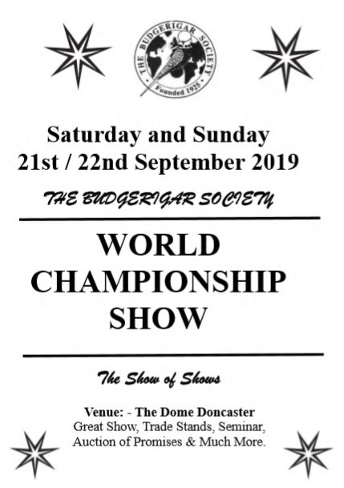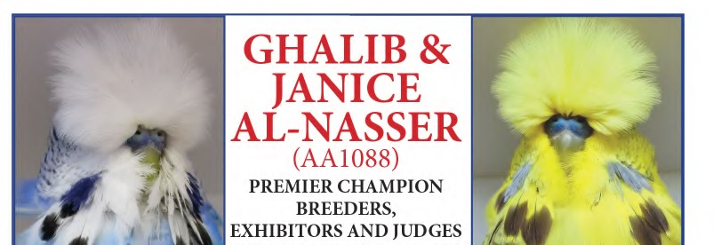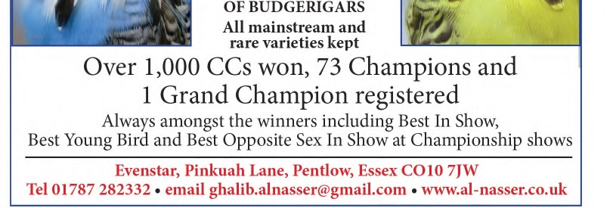

12

