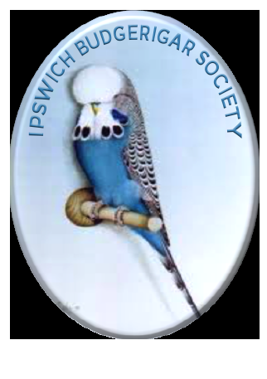**Ipswich Budgerigar Society Events Diary 2018.**

*Suffolks Premier Club for Budgerigar Keepers.*

Meeting at the Constable Hall, Gandish Rd, East Bergholt.

19:45 – 22:00.

New Members are always welcome.

January 25th – AGM and Member of the Year.

February 22nd – Speaker – **Gavin Carter** – local judge and wealth of knowledge.

Colour Comp – Class 1- Any Normal Green Series bird Inc. Grey Green.

Class 2- Any Normal Blue Series bird Inc. Grey.

Class 3 – Any Pied Variety Inc Dark Eyed Clears.

March 22nd – Members Panel Night – Test their knowledge / gain some advice.

April 26th – Whats my Bird? – Fun night

Colour Comp- Class 4 – Any Normal Cinnamon or Opaline Cinnamon.

Class 5 – Any Colour Spangle Inc. Double factors

Class 6 – Any Red eyed Variety.

May 12th / 13th – Aviary Visit - details to be finalised.

May 24th – Speaker - **Harry Hockaday** – a night not to be missed.

June 10th – Annual B.B.Q and club show at Peter and Sandra’s at Langham.

June 28th – Members night and Judging comp

July 26th – Pre –Show prep and Update.

July 29th – **Annual Open Show** – Our 50th Show.

August 23rd – Speakers – **James and Sandra Gillan** – World Champions.

Sept 20th/27th – Essence of a Pair and Pairs night.

Colour Comp- Class 7 – Any Opaline Blue or Green series Inc Grey Factor.

Class 8 – Any Rare Variety.

Class 9 – Any Yellow-face Variety

Oct 25th - Speaker – **Geoff Tuplin** – a fantastic speaker and a rare opportunity for Members and Pete’s Swindle

Nov 15th - Auction and Social Evening.

Dec 13th - Xmas Meal.

Jan 24th 2019 - AGM.